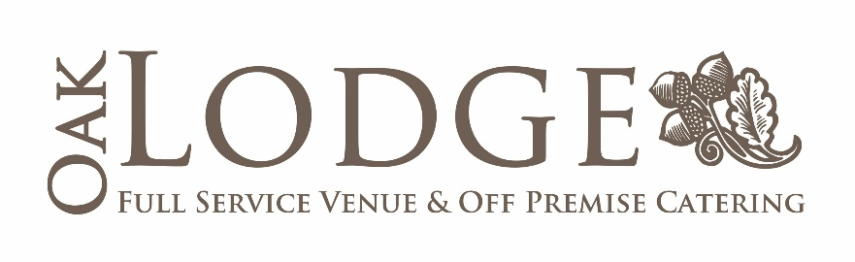
2834 S. Sherwood Forest Boulevard, E-1
Baton Rouge, LA 70816
Phone: (225) 291-6257
andi@oaklodgeonline.com
deborah@oaklodgeonline.com

Off-Site Catering Information
Revised August 2018

Off-Site Package | $32.00 per Guest*
- Three Hours of Service
- Service on Quality Plastic Dinnerware and Serving Utensils
- Table Linens and Décor for the Buffet Tables, if needed
- Your Choice of Lemonade or Iced Tea
- Qualified, Attentive, and Professionally Dressed Servers
- Experienced Coordinator Onsite to Assist

Enhancements:
- Glassware for the Bar: $5.00 per Person
- Glassware for the Cuisine: $5.00 per Person
- Additional Table Linens: $4.00 per Linen
- Tables: $25.00 per Table (includes linen)
- Chairs: $8.00 per Chair
- Additional Hour: $600.00 per Hour
- Additional Waitstaff: $100.00 per Server

* 18% Service Charge and 9.45% Sales Tax will be Applied to All Food and Beverage Charges
Menu Selections

Butler Passed Items ($2.50 per Guest per Item)
- Antipasto Skewers with Salami, Cheese, and Olives
- Mini Meat Pies
- Mini Crawfish Pies
- Smoked Salmon Pinwheels
- Fruit and Cheese Skewers
- Ham and Pineapple Skewers
- Bacon-Wrapped Shrimp ($3/Guest Upcharge)

Hot Choices (Choose 2)
- Marinated Grilled Chicken Tenders with a Honey Mustard Sauce
- Seafood Stuffed Mushrooms
- Italian Stuffed Mushrooms
- Crabmeat Mornay with Crackers
- Spinach Madeline with Crackers
- Crawfish Dip with Crackers
- Broccoli Cheese Dip with Crackers
- Homemade Meatballs with Your Choice of Marinara, Sweet & Sour, or Barbeque Sauce
- Spinach and Artichoke Dip with Crackers
- Crabmeat Au Gratin with Crackers
- Baked Spicy Hot Wings

Cold Choices (Choose 3)
- Salmon Pinwheels
- Jalapeño Cheese Squares
- Asparagus Cheese Squares
- Fiesta Corn Dip with Chips
- Spinach Dip with Water Chestnuts
- Festive Mexican Bean Dip with Chips
- Pepperoni Tortilla Roll-Ups with Salsa
- Cold Spicy Shrimp Dip with Crackers
- Deviled Eggs
- Ham and Asparagus Pinwheels
- Mini Muffalettas
Cold Choices Continued
- Assorted Cheese Board with Your Choice of Cheese Ball – Spicy Yellow Cheese Ball; Pineapple Cream Cheese Ball; or Tropical Fruit Cheese Ball with Dried Fruit, Coconuts, and Pecans
- Crawfish Bread
- Chocolate Dipped Strawberries
- Antipasto Display with Salami, Assorted Cheeses, Olives, and Marinated Vegetables
- Chicken Salad with Walnuts on Fresh Croissants
- Finger Sandwiches – Honey Baked Ham, Turkey, or Roast Beef
- Plantation Sandwiches on Freshly Baked French Bread

Entrees (Choose 2)

- Your Choice of Shrimp or Crawfish Étouffée – Served with Steamed White Rice
- Chicken and Sausage Jambalaya
- Your Choice of Shrimp or Crawfish Bowtie Pasta
- Blackened Chicken Alfredo with Penne Pasta
- Marinated Cold Pasta Salad with Shrimp and Vegetables
- Chicken Sharone with Rotini Pasta in a Spicy Cream Sauce
- Smoked Beef Brisket with Condiments and Fresh Rolls
- Cajun Spiced Turkey with Condiments and Fresh Rolls
- Black Forest Ham with Condiments and Fresh Rolls

Menu Enhancements

- Raspberry Hazelnut Mascarpone Torte | $3.00 per Guest (Min. of 75 Guests)
A TRUE Oak Lodge Specialty! Rich Mascarpone Sweetened with Hazelnut and Topped with Raspberry and Toasted Pecans and Adorned with an Amazing Fruit Display. Served with Water Crackers. This is a treat your guests will always remember!

- Jumbo Boiled Shrimp Station | $6.00 per Guest
Laissez les bon temps rouler! Deliciously seasoned jumbo shrimp are placed in our little Louisiana pirogue and mixed with lemon halves. This beautiful Cajun display is sure to please.

- Assorted Dessert Display | $3.00 per Guest
Your guests will love our Chef’s assortment of desserts which might include chocolate chunk brownies, lemon bars, meltaway bars, cheesecake bites, and pecan pralines. Have a special request? Just let us know when you’re planning your menu.

- Chocolate Fountain | $3.00 per Guest
Rich milk chocolate flows throughout your party for a delicious decadence. Adorned with fresh fruit, marshmallows, chocolate chip and sugar cookies, this choice is sure to be a hit.

Beverage Selections

Alcohol and Nonalcoholic Packages:

- Soft Drinks – $2.00/Guest
  - Coke, Diet Coke, Dr. Pepper, and Sprite

- Champagne – $5.00/Guest

- Draft Beer and Wine - $10.00/Guest
  - Draft Beer and Your 4 Choices of Wine: Chardonnay, White Zinfandel, Moscato, Pinot Grigio, Rosé, Cabernet Sauvignon, Pinot Noir, and Merlot

- Bottled Beer and Wine – $12.50/Guest
  - Assorted Bottled Beer (5 Domestic Brands), and Your 4 Choices of Wine: Chardonnay, White Zinfandel, Moscato, Pinot Grigio, Rosé, Cabernet Sauvignon, Pinot Noir, and Merlot

- Party Package – $14.00/Guest
  - Assorted Bottled Beer (5 Domestic Brands); Your 4 Choices of Wine: Chardonnay, White Zinfandel, Moscato, Pinot Grigio, Rosé, Cabernet Sauvignon, Pinot Noir, and Merlot; and a “Signature” Drink

THE FOLLOWING PACKAGES INCLUDE SOFT DRINKS:

- Full Well Brand Open Bar - $17.00/Guest
  - House Brand Liquors Plus Wines, Assorted Bottled Beer (5 Domestic Brands), Your 4 Choices of Wine: Chardonnay, White Zinfandel, Moscato, Pinot Grigio, Rosé, Cabernet Sauvignon, Pinot Noir, and Merlot; and a “Signature” Drink

- Full Premium Open Bar - $20.00/Guest
  - Crown Royal, Jack Daniels, Johnny Walker Black Label, J & B, Grey Goose, Belvedere and Many More! Also Assorted Bottled Beer (5 Domestic Brands), Your 4 Choices of Wine: Chardonnay, White Zinfandel, Moscato, Pinot Grigio, Rosé, Cabernet Sauvignon, Pinot Noir, and Merlot; and a “Signature” Drink

